Day6 Revisit

**TypeScript**

Strongly typed super set of JavaScript.

Typescript is developed by Microsoft.

Typescript is highly secured and used in all places where java script can be used.

Typescript = JavaScript + Additional Features

Typescript will be transpiled to JavaScript by the Typescript compiler (tsc)

tsc = typescript compiler

Typescript also case sensitive language similar to Javascript

All the typescript files will have .ts extension

Typescript is used in many modern javascript based framework.

**React**

React is a very popular javascript based library mainly used to create rich user interface (Rich UI)

React is developed by facebook.

React used virtual Dom

React is a component based js library.

Component is the re-usable piece of code to generate UI.

Component consist of both data and view to display the data.

Using React component, we can create custom HTML tags. (User defined html tags)

React is used to create SPA (Single Page Application)

Types of Component

1. Stateful component (Class based component)
2. Stateless component (Function based component)

Ex: **Stateful Component (Class based component)**

Import React from ‘react’;

class Welcome extends React.Component {

render() {

return (<div> Simple React component </div>);

}

}

export default Welcome;

Ex: **Stateless component (Function Based Component)**

Import React from ‘react’;

function MyComponent () {

return (

<div>Custom Component created by React.!!! </div>

);

}

Export default MyComponent;

React App will have only one HTML page (web page) index.html

In React SPA (Single Page Application) many components (Assume it as a sticky note)

Each component is a custom html tag.

<Siva /> (You can add this custom html tag in App.js or Index.js)

Class Siva extends React.Component {

render() {

return( <div>This is a Custom HTML tag!!! </div>);

}

}

export default Siva;

React uses the concept of Virtual DOM

* Create-react-app (CLI – Command Line Interface)
* CLI is useful in creating the application along with all other dependencies to compile, test, run and debug the application
* Command VS CLI [Command will do a single operation or task (Like creating a file/folder, reading a file), CLI will do many/multiple operations like creating fully functional applications along with all other dependencies.

Attribute of the custom html tag is called as props in React.

Custom html tag (component) can have n number of props.

Way of creating React application

create-react-app -- is a CLI used to create React Application along with all dependencies.

We Need Node.js to create React application.

Syntax:

npx create-react-app <app-name>

Example :

npx create-react-app my-app;

Starting/Building/Running the React application

Cd <app-name>

npm start

React server will use port number 3000 to run the react application.

1. Create a New folder called ReactWS (React Workspace)

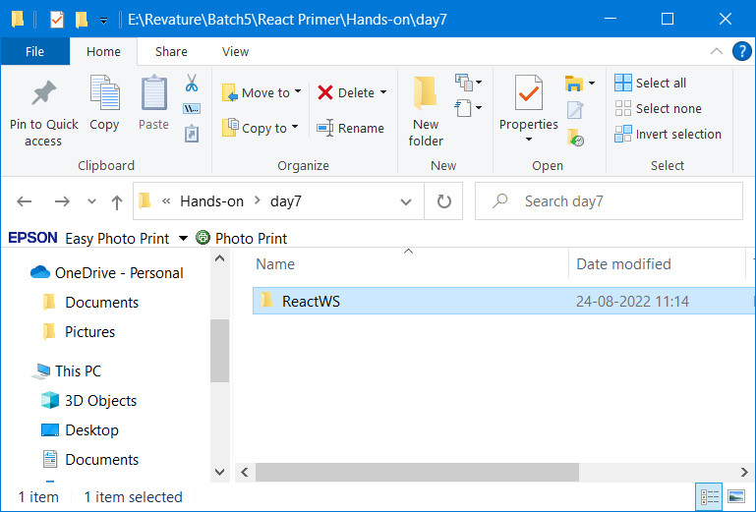

1. Open VS Code from this location

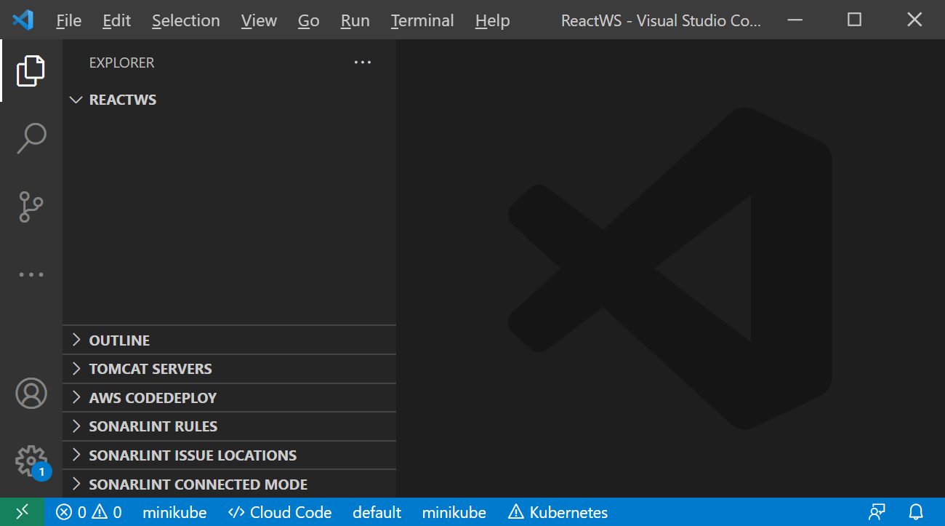

1. Open the Terminal in VS Code (Ctrl+` or View🡪Terminal)

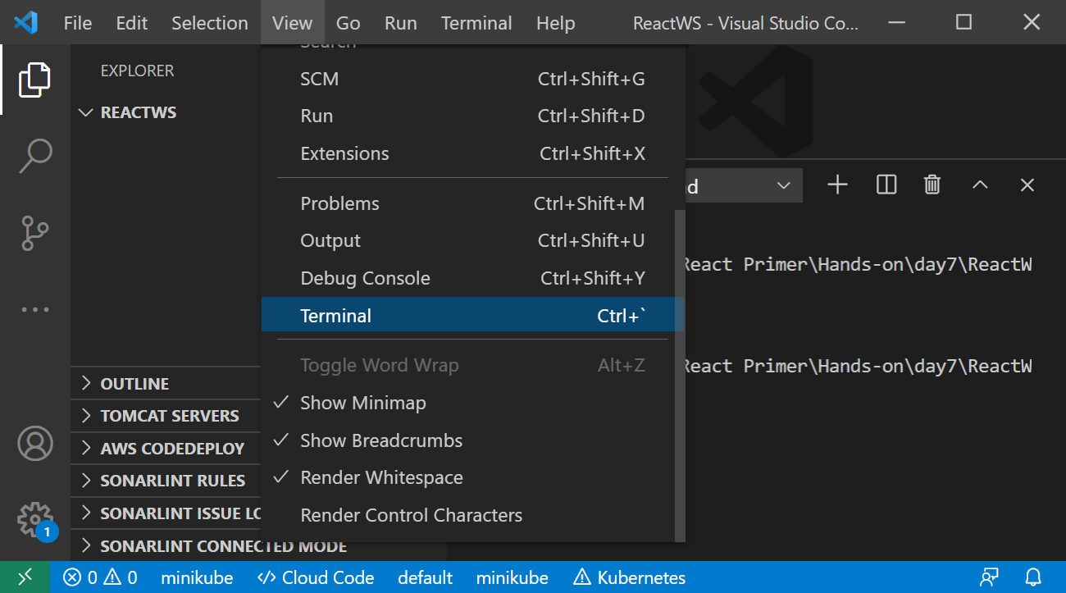

1. Check Node & npm version from the terminal (node -v, npm -v)

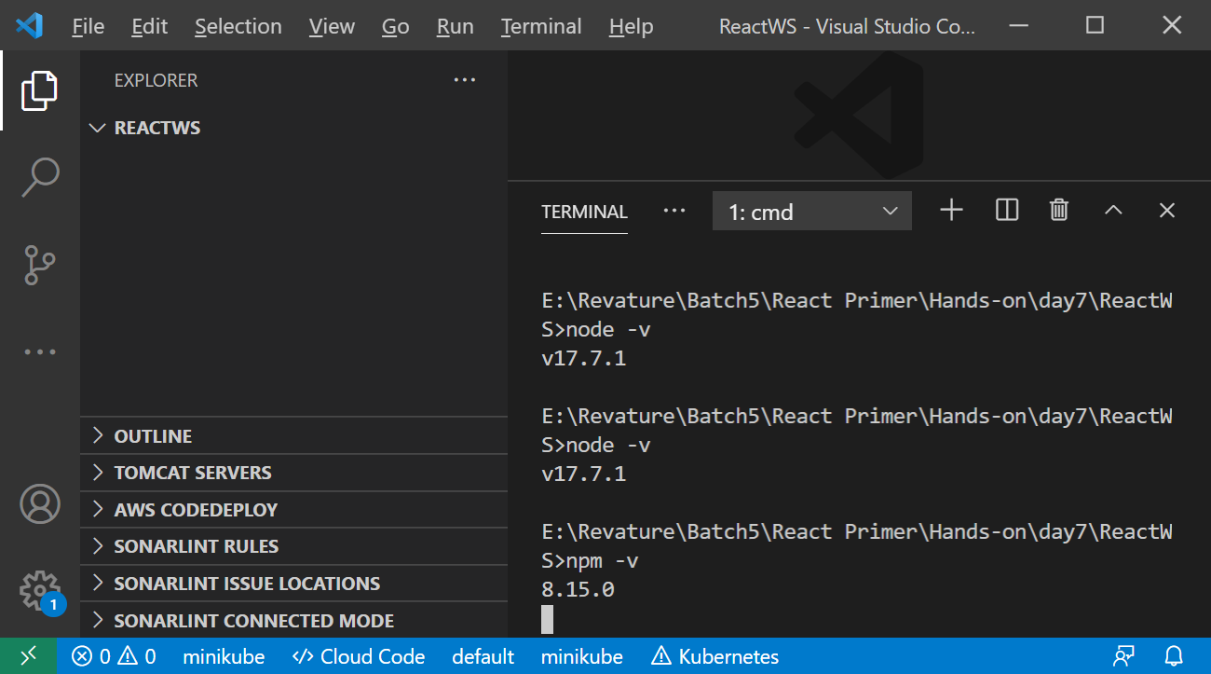

1. Type npx create-react-app first-app

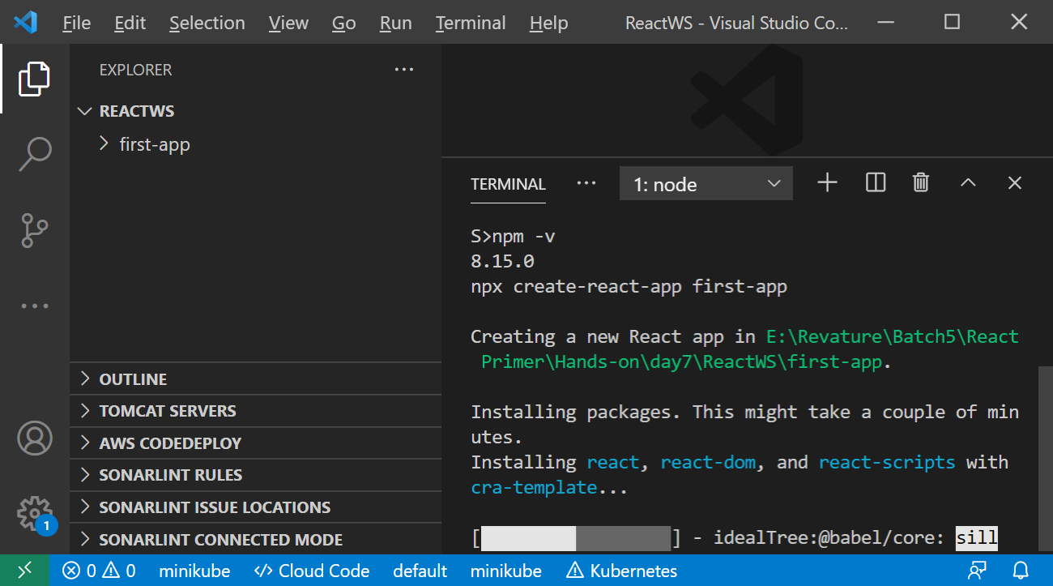

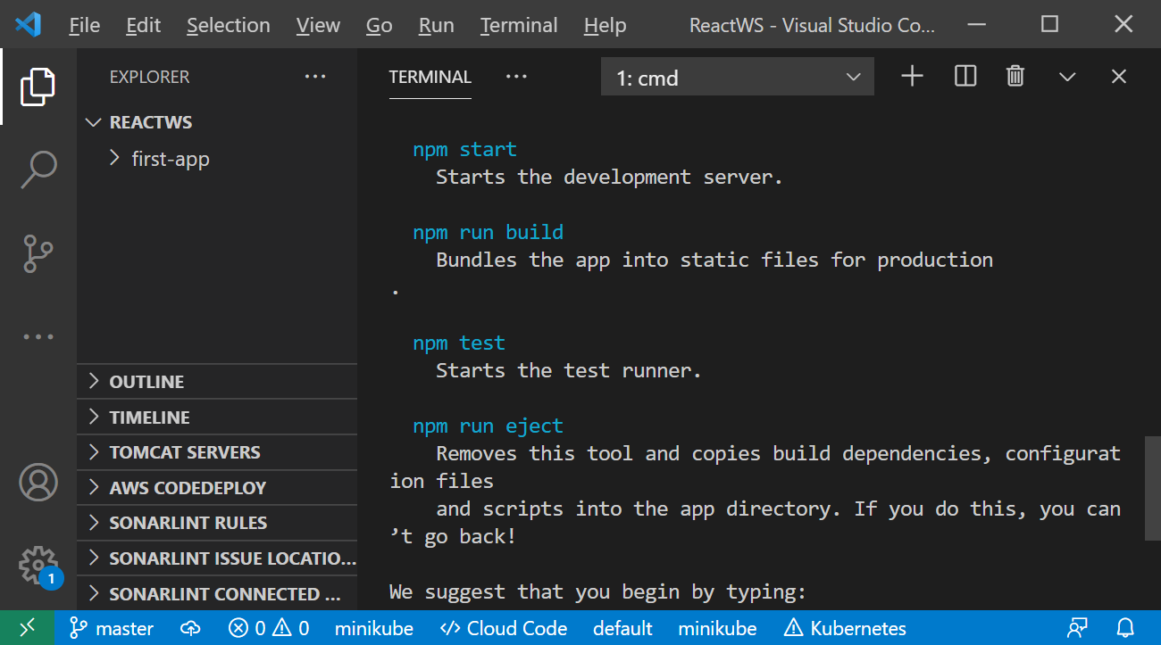

1. Cd first-app
2. npm start

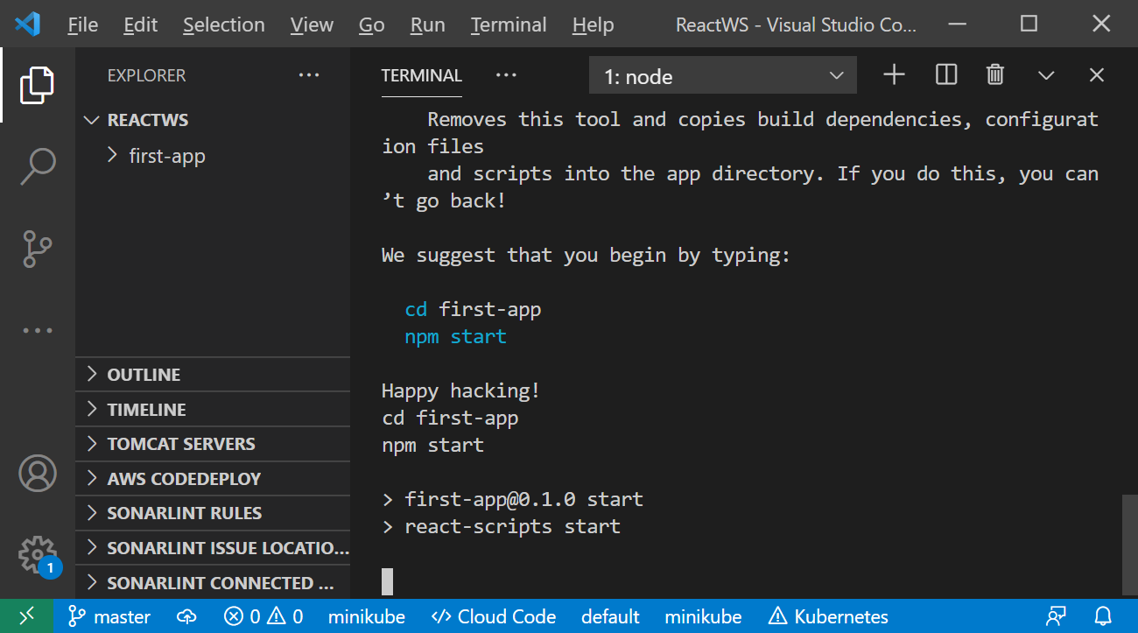

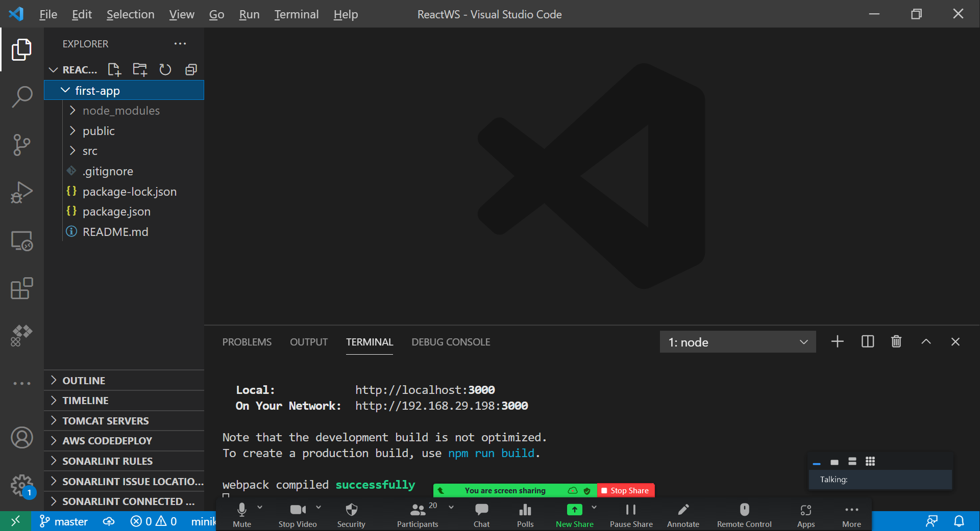

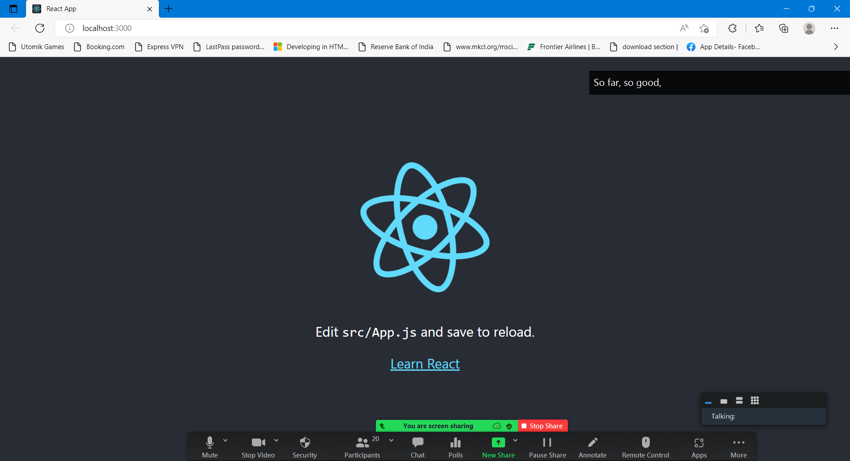

New folder (ReactWS)

Node -v, npm -v

Npx create-react-app first-app

Cd first-app

Npm start

When we are downloading a react application from Github or internet (Node_modules) libraries/dependencies will not be available.

After extracting the source code, we need to execute “npm install” command to download all the dependencies & libraries in a folder called “Node_Modules”

Our first component siva.js

import React from 'react';

//Stateful component or Class based component (Custom HTML tag - Userdefined HTML tag)

class Siva extends React.Component {

    render() {

        return (

            <div>

                <h2> This is Class based Component</h2>

            </div>

        );

    }

}

export default Siva;

<html> (Parent)

<head> </head> (child1)

<body> </body> (child2)

</html>

In the above example head & body elements are siblings (They belongs to same parent)

<html> (Parent)

<head> (child1)

<title>Home Page </title> (Grand Child)

</head>

<body> (child2)

<p> </p> (Grand Child 1)

<p> </p> (Grand Child 2)

<p> </p> (Grand Child 3)

</body>

</html>

<App> <Siva> -- They are siblings (defined in index.js)

<App> <Another> - They have parent & child relationship (Another is defined inside App component)

JSX syntax is the combination of Java Script + XML (HTML)

Pls create Function based HelloWorld Component and call it inside the App.js (root component)

import React from 'react';

function HelloWorld (){

    return (

        <h3>Hello World !!!</h3>

    );

}

export default HelloWorld;

<https://www.youtube.com/watch?v=dGcsHMXbSOA&list=PLDyQo7g0_nsVHmyZZpVJyFn5ojlboVEhE>

Props & State

Props are nothing but the attributes added to the custom tag.

Props is a single object contains all the properties/attributes passed to that component.

<img src=” “ height=” “ width=” “/>

Src, height and width are attributes attached with img tag.(Image)

Similarly while creating custom HTML tags using react, we can pass some attributes to that tags, This attributes are called as props of Component.

Props are mainly used for inter-component message passing. [One component can send message to another component using props]

Parent component can pass props to child component.

Components are re-usable piece of code. (Custom HTML tag)

**State**

State is a JS Object which stores the Dynamic data and decides how to render the data.

Unlike props, state is private to component.

State is immutable, you can’t modify the state directly. You need to modify the copy of the state using setState() method.

ComponentDidMount(), componentWillUnmount()

Event Handling

Type of Events

1. Keyboard Events
2. Mouse Events
3. Forms/Window Events
4. Page events

onclick == HTML Event

onClick == React Event